The Data Extraction Tool User’s Manual

Name: Simon He

Email: simon.dl.he@philips.com

This software tool is for data extraction from PCK lighting fixtures test station. It can help us to gather the data from massive discrete reports into an excel file for analyze.

1. Double click the icon of the tool: DigData.exe

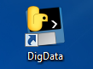

1. Pop up a window to select the folder which the CSV files of the test station you want to extract. Select one file and click “Open”.

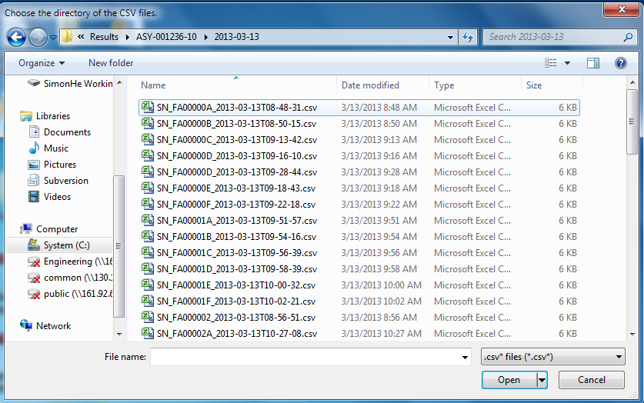

1. Then pop-up a box to select the product name. This name is configured in Config.v file. If there is no name of your product, you and add for yourself or contact me to add into the file.

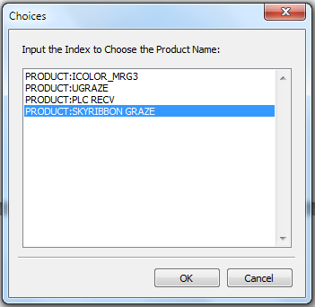

1. Select the test station name of the product. Different production may have different test process, so please confirm your test station is listed in this box.

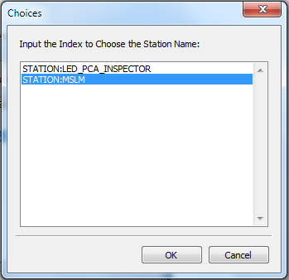

1. If the test results in this station have different format due to different type. Such as 1FT, 2FT, 3FT, 4FT or eW, iW, RGB, etc. You will have to select one type.

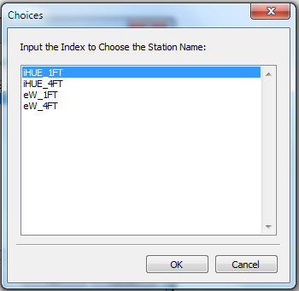

1. Input the file name which you want to generate.

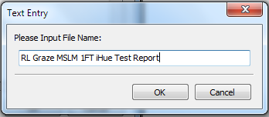

1. After few seconds, the result will convert to an excel file. This file is in the folder name “Result” which located in the selected folder.

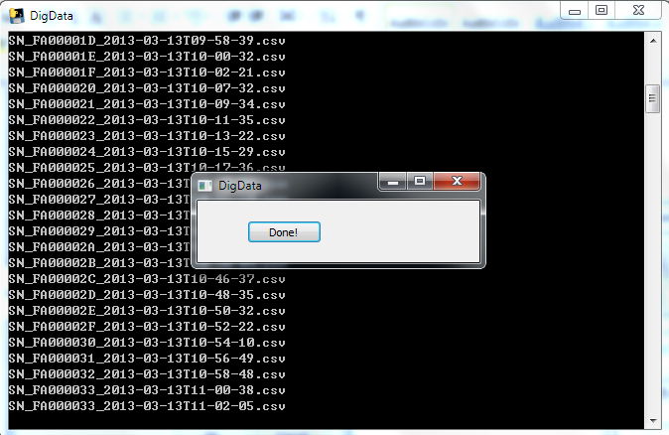

1. Open the file and do some analyze for you own.

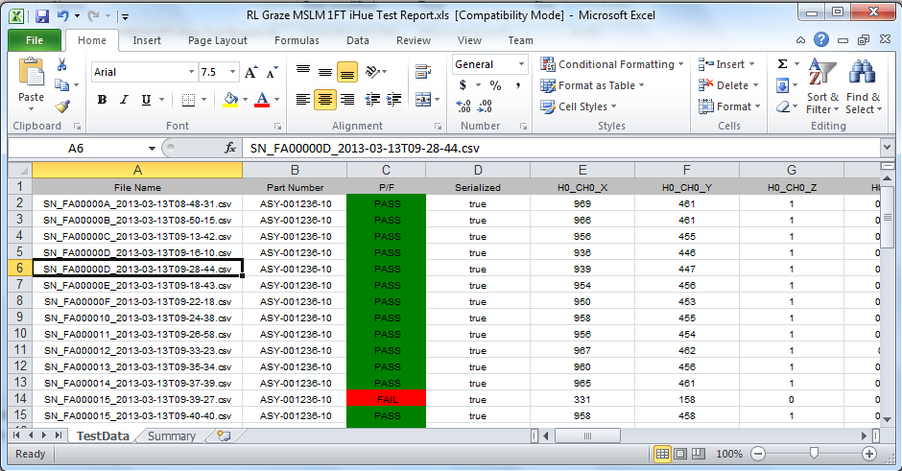

1. If you choose the wrong type, you will get wrong data from the CSV files.

For LED Inspector test station, the test results are zip to a zip file. So you will have to extract the CSV file out and then run the application.

Appendix 1: The structure of Config.v

The format of generated test report is determined by the config.v file. This file specifies the Product name, Station name, and Fixture type and cell info of the test result.

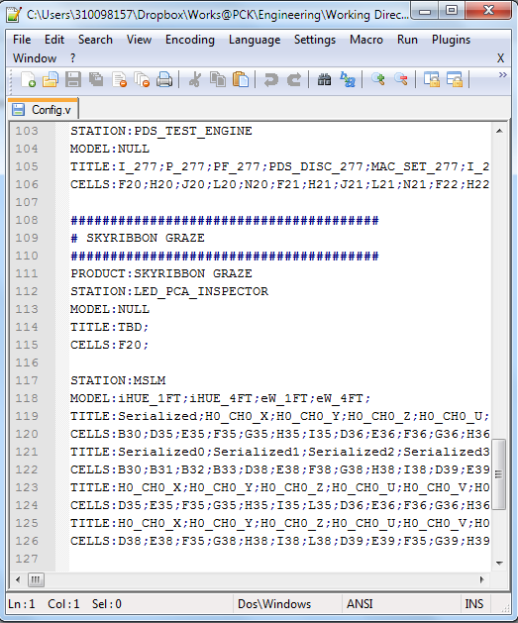

You can modify it if you want to add a new product/station or fixture type. Or specify a new report format if you just want some of the test info.

The file structure is as follows:

1. Comment for product name. This will not recognize by the software. Just for us to read. Start with “#”

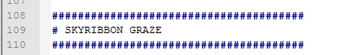

1. Product Name.



1. Station Name.



1. Fixture Type. If there is only one model, you can just use “NULL”.



1. Specify the Report Cell title and Cell location

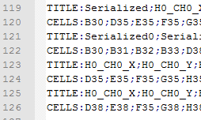

Title is for generate the title in the excel file, you can use the name of your favorite. Cells is the location which you want to extract in the CSV file. You can open the CSV file in Excel and check the location and then write into the config.v file.

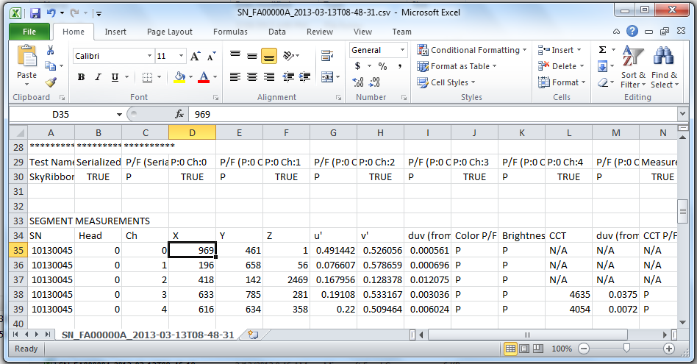

Appendix 2: List of current data supported

|  |  |  |  |
| --- | --- | --- | --- |
| No. | Product Name | Station Name |  |
| 1 | ICOLOR_MRG3 | DRIVER_PCA_FTE |  |
|  |  | LED_PCA_INSPECTOR |  |
|  |  | LIGHT_MEASUREMENT |  |
|  |  | LED_POST_BURN_IN_INSPECTOR |  |
| 2 | UGRAZE | POWER_PCA_FTE |  |
|  |  | LED_PCA_INSPECTOR |  |
|  |  | LIGHT_MEASUREMENT |  |
| 3 | PLC_RECV | PDS_TEST_ENGINE |  |
| 4 | SKYRIBBON_GRAZE | LIGHT_MEASUREMENT |  |
| 5 | ARCHIPOINT | FTE |  |
|  |  |  |  |
|  |  |  |  |
|  |  |  |  |